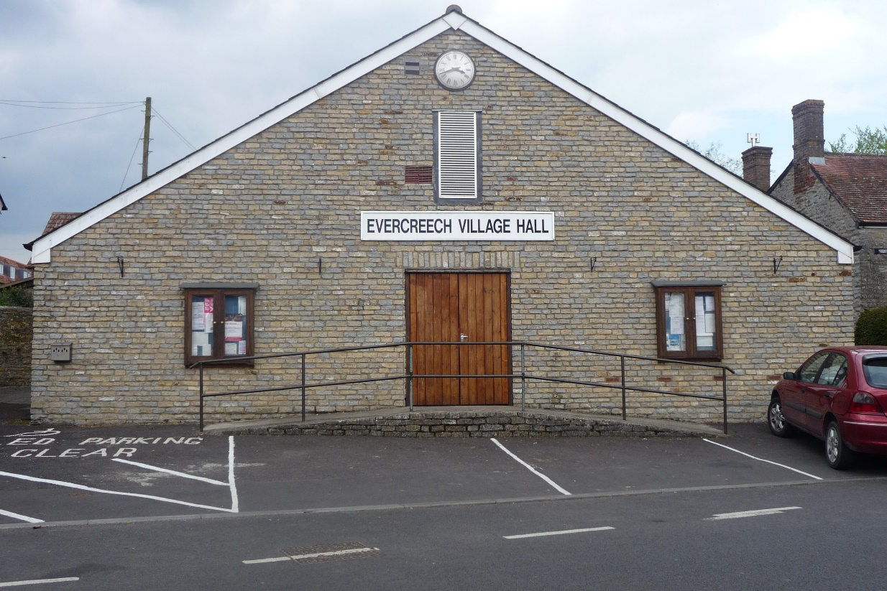

Evercreech Village Hall was built in 1934 and is located in the village square in the centre of the village. Although the Hall is over 80 years old it has been subject to continuous improvement to provide comfortable facilities for everyone.

There is a large entrance lobby with full wheelchair access through large double doors into the main hall, there are no steps to contend with and the floor is level and smooth.

We can offer a large main hall complete with a full stage, bar area and full kitchen as well as a smaller meeting room with its own access.

Main Hall
Rear Hall
Bookings
Committee

MAIN HALL

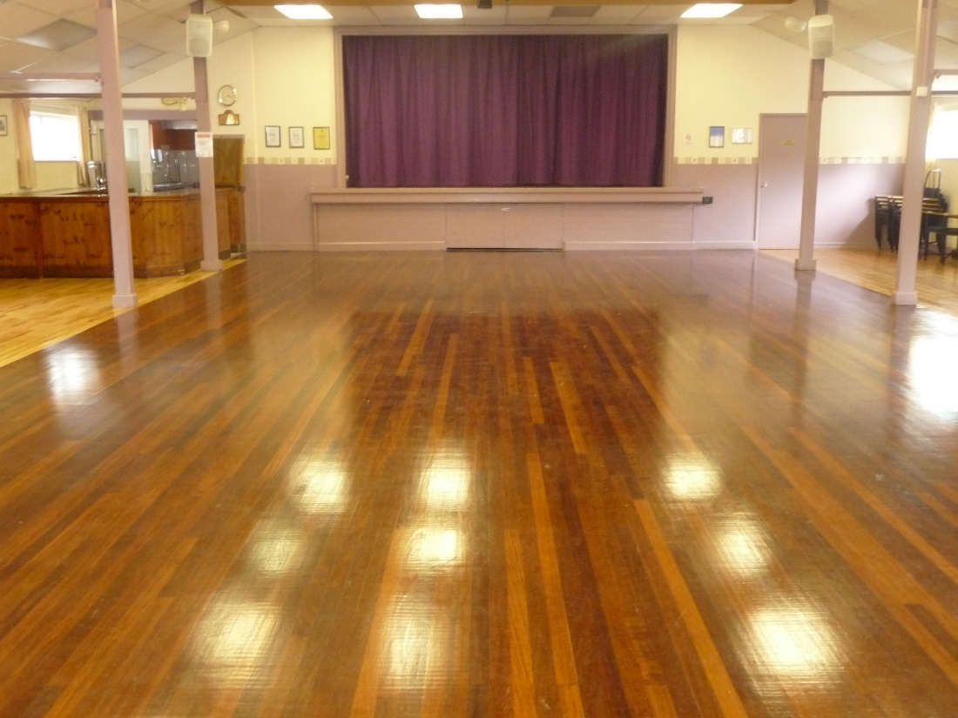

The large main hall has an approximate floor area of 2000 sq.ft/186 sq.m, not including the stage. It is heated by warm air central heating with a pre-set thermostat located in the hall. In addition, the hall offers a bar area that leads through to a fully equipped kitchen.

The hall will accommodate:- 350 people seated theatre style; 150 people for dancing when seating is provided at tables; 165 people for dancing with just seating provided;

The main kitchen is accessed from the main hall through the bar area. It can also be accessed from the rear lobby and hallway. The modern kitchen has a four-ring electric hob, double oven, 'fridge, dishwasher and microwave. There is a double sink unit plus a separate hand wash basin. The kitchen is suitable for catering for a large event or for serving coffees and snacks. In addition, there is a 'fridge in the bar area.

The main hall also has a fully curtained stage area of approximately 240sq.ft/22sq.m. We boast an advanced presentation system in the main hall that can relay direct from a laptop with a ceiling mounted projector and an electric screen that drops down over the stage. There is a separate control room fitted with a full mixing desk for use when putting on plays with multiple speakers, special effects and theatre lighting. A ‘sound loop’ system operates within the hall so that a large audience can clearly hear a speaker from the front. The hall also benefits from an induction loop system for the hard of hearing.

All the lighting in the main hall is powered by LED panels with individual dimmer switches so the level of lighting required can be determined by the hirer.

REAR MEETING ROOM

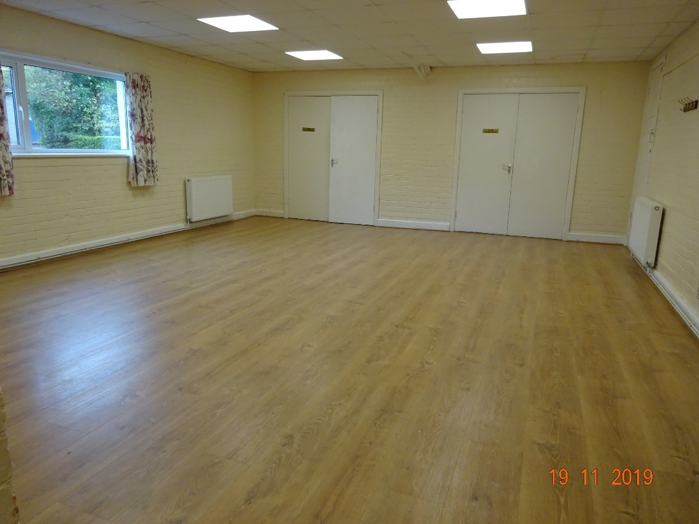

We can also offer a smaller committee/meeting room of approximately 300 sq.ft/28 sq.m that has its own small kitchen (no cooking facilities) and unisex toilets.

This room can be used for smaller groups or classes and has doors that can access the stage from the rear when the hall is being used as changing rooms during a drama production.

It has its own separate access but can also be accessed through the main kitchen and used as a buffet area if there are a large number of people using the main hall. This small hall provides tables and chairs and is heated by modern radiators controlled from a central thermostat.

HALL BOOKINGS

If you would like to enquire about booking the hall, please email us on:- evercreechvh@gmail.com or contact Janet Rundle on 01749 830800.

All bookings are subject to our Conditions of Hire and all Hirers are required to sign a Hire Agreement form and, if applicable, a Hire Licence Agreement form.

A deposit of £100 will be required with all bookings, refundable if no damage to the hall was incurred or an unacceptable level of cleaning needed following the event.

We have appointed a Designated Premises Supervisor if you should wish to sell alcohol at your event. If you prefer to make your own arrangements, then you can apply for a Temporary Event Notice from Mendip District Council. We also hold a Performing Rights Society Licence so that music can be played at your event.

Our hire charges include all heating and lighting. There is no charge for the kitchen when it is just used for provision of tea/coffee.

HIRE CHARGES | Local Organisations/Charities | Private Parties with bar /Commercial Use
Main Hall  Rear Hall | £10.00 per hour (incl. children's parties)  £9.00 per hour | £20.00 per hour  £18.00 per hour
Set Up on previous day | £9.00 per hour | £18.00 per hour
Use of main hall kitchen for full catering use | £2.00 per hour | £2.00 per hour

COMMITTEE

The Village Hall is a registered charity and is administered by the Trustees, also known as the Management Committee. The Committee comprises 8 elected members and 10 group representative members. Any ‘not for profit’ groups that hire the Hall on a regular basis are entitled to a place on the management committee.

We believe in the principles of Open Accessibility, Equal Opportunities, Health and Safety and Human Rights. We want everyone to feel welcome, safe and comfortable in our Village Hall and enjoy the time that they spend there.

Please let us know if you feel there is anything more we could do to make your time with us more pleasant.

The elected officers are:-

Chair: | Mollie Purse MBE | Tel: 01749 830166
Secretary: | Marion Covens | Tel: 01749 830239
Treasurer: | Richard Kewish | Tel: 01749 830665
Hall Bookings | Janet Rundle  Email: | Tel: 01749 830800  evercreechvh@gmail.com

