Do you know about the Patient Participation Group
at Park Medical Practice?

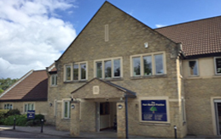

The Patient Participation Group (PPG) is a small group comprising patients, GPs and the Practice Manager. The Chair is Robert Goodhand.

The PPG acts as a link between patients and the GP Practice. It is a forum for collating patient views, identifying common themes and giving feedback to the surgery. It also acts as a group for consultation on some changes and developments, and for communicating ideas and changes.

We issue a regular Newsletter which is available on the web site by clicking the “Patient Group” link on the home page. The Newsletter provides patients with updates from the surgery on matters such as staffing, vaccination services and new developments.

If you are a patient of the surgery and would like to have a say, or impact on how our local GP services develop, please get in touch. We welcome views, or ideas that might help the Practice become the best it can possibly be, valued and trusted by patients.

We would also like to hear from anyone interested in joining the PPG. There are 5 or 6 meetings during the year, we are a friendly crew and you would be very welcome.

To contact the local PPG you can e mail us at:
reception.parkmp@nhs.net. Please mark your email “For the attention of the PPG”

Your local contact is:

